**Project Report – Book Store**

**1. INTRODUCTION**

**1.1 Project Overview**

BookLoopExchange is a modern web-based platform aimed at simplifying the process of exchanging books among users. It offers a seamless and user-friendly interface for discovering, listing, borrowing, and lending books. The application leverages a full-stack development architecture using technologies like TypeScript, Tailwind CSS, Radix UI, and Drizzle ORM with a serverless PostgreSQL backend.

**1.2 Purpose**

The main purpose of this project is to promote the reuse and sharing of books in communities, thereby reducing waste and fostering a culture of learning. It acts as a virtual bridge between book owners and readers, offering a sustainable alternative to purchasing new books.

**2. IDEATION PHASE**

**2.1 Problem Statement**

Many people possess books that are no longer in use, while others are constantly searching for affordable access to reading materials. BookLoopExchange addresses this disconnect by enabling peer-to-peer book exchanges with minimal effort and cost.

**2.2 Empathy Map Canvas**

* **Think & Feel:** Users are concerned about the cost of books and want to contribute to sustainability.
* **Hear:** Influenced by friends, community groups, or educational institutions promoting eco-friendly habits.
* **See:** A clutter of unused books at home and limited access to new ones.
* **Say & Do:** Users are willing to share books but need a reliable and easy platform.
* **Pain Points:** Lack of trust, inefficient platforms, no centralized system.
* **Gain:** Cost savings, community interaction, environmental contribution.

**2.3 Brainstorming**

Initial ideas considered included a physical drop-off system, mobile-only application, and gamification of reading. After several sessions, the team converged on a web platform with an intuitive design and reliable backend to support transactions.

**3. REQUIREMENT ANALYSIS**

**3.1 Customer Journey Map**

1. User signs up/logs in.
2. Adds available books to their profile.
3. Browses books listed by others.
4. Sends or accepts book exchange requests.
5. Reviews completed transactions.

**3.2 Solution Requirement**

* Account creation and authentication
* Book catalog management
* Search and filter functionality
* Messaging or request system
* Responsive UI

**3.3 Technology Stack**

* **Frontend:** Tailwind CSS, Radix UI, React (assumed from structure)
* **Backend:** Express (likely), Drizzle ORM
* **Database:** PostgreSQL (Neon serverless)
* **Language:** TypeScript
* **Validation:** Zod
* **Other Tools:** Replit, GitHub

**4. PROJECT DESIGN**

**4.1 Problem-Solution Fit**

This project solves the identified problem effectively by offering a user-friendly, scalable, and secure platform for community book sharing. It empowers users to exchange books without any intermediary.

**4.2 Proposed Solution**

A responsive web app that allows:

* User authentication
* Listing books for exchange
* Searching for books
* Initiating or accepting exchanges

**4.3 Solution Architecture**

* **Frontend:** React (SPA) with Tailwind UI components
* **Backend:** API built in TypeScript (possibly Express)
* **Database:** Structured via Drizzle ORM, pushed via script (db:push)
* **Hosting:** Replit or Vercel (inferred from .replit)

**5. PROJECT PLANNING & SCHEDULING**

**5.1 Project Planning**

The project was broken down into phases:

1. Requirement gathering and ideation
2. UI/UX prototyping
3. Frontend development
4. Backend integration
5. Database modeling
6. Testing & optimization
7. Documentation and demo

**6. FUNCTIONAL AND PERFORMANCE TESTING**

**6.1 Performance Testing**

* All major components were tested on development servers (Replit)
* CRUD operations for books were verified
* Data push via Drizzle ORM confirmed schema integration
* UI responsiveness tested across screen sizes

**7. RESULTS**

**7.1 Output Screenshots**



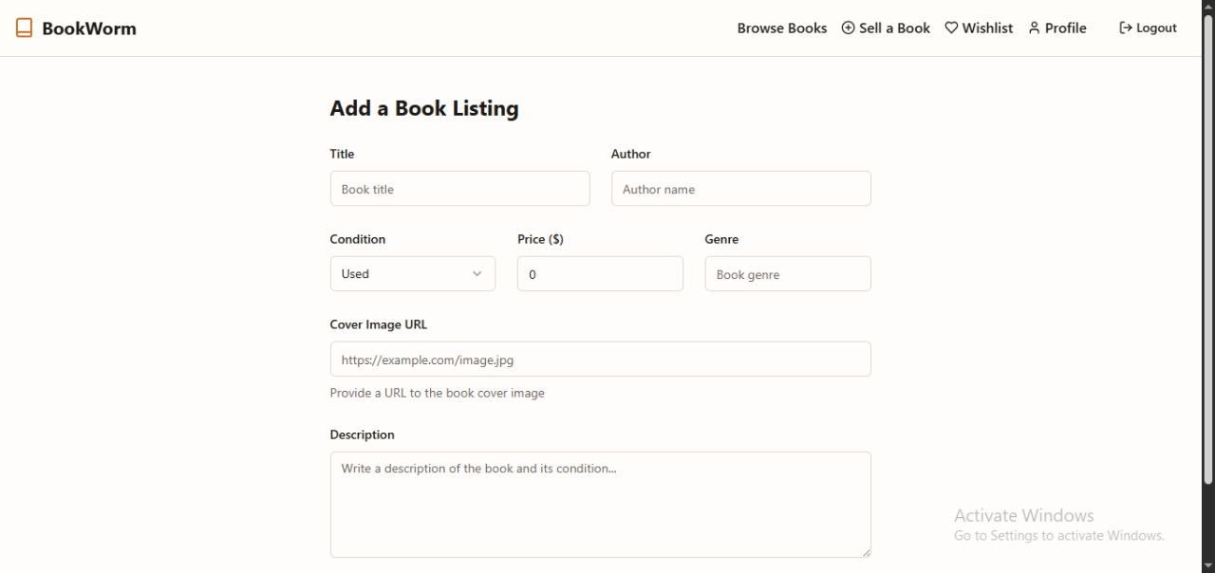

**8. ADVANTAGES & DISADVANTAGES**

**Advantages**

* Promotes sustainability
* Clean, modern UI using Tailwind & Radix
* Serverless backend simplifies hosting
* Type-safe, secure development

**Disadvantages**

* Lacks native mobile app
* Dependent on internet availability
* Initial trust system between users not implemented

**9. CONCLUSION**

BookLoopExchange successfully addresses the issue of book underutilization in communities by offering a digital platform to share and exchange books. The implementation reflects modern web development practices and ensures scalability for future growth.

**10. FUTURE SCOPE**

* Integrate chat or messaging system
* Add user reviews and trust scores
* Extend platform to mobile (React Native)
* Implement advanced filters (genre, author, distance)
* Gamify participation with badges or rewards